Letter of Intent - Semiconductor Bandgap Measurements

**Theoretical Motivation**

The objective is to determine the band gap of silicon based on the temperature-dependent behavior of silicon's resistivity. As temperature increases, intrinsic carrier concentration within silicon rises due to thermal energy enabling electrons to transition from the valence band to the conduction band. This phenomenon leads to a marked decrease in resistivity, observable through resistivity measurements. By analyzing how resistivity changes with temperature, particularly in the high-temperature regime where intrinsic carriers dominate, we can deduce silicon's band gap energy [1]. This method provides a direct link between fundamental semiconductor physics—specifically, the relationship between band gap energy, carrier concentration, and resistivity—and practical measurements, offering an approach to characterizing silicon's properties.

**Experimental Setup:**

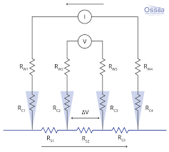Our setup will employ the Four Probe Method (refer to image on the right). It utilizes two outer probes to supply a constant current, maintained by compliance voltage controlled by a Keithley source meter. Two inner probes, connected to voltage meters, will measure the voltage drop, allowing for resistivity assessment. A ceramic oven, regulated by a Micromega power supply, will facilitate precise temperature adjustments.

We will start with $1 μA$ of current, never going above $50 μA$ as this will cause oxidation, changing resistance. Compliance – Voltage Regulated – $21 V$ for $1 μA$.

**What Measurements we will take:**

The experiment centers on recording the semiconductor’s voltage response to varied temperatures under a constant current, set initially at 1 $μA$ to prevent oxidation. These readings will help us track resistivity and conductivity shifts, from which we should be able to estimate the band gap energy at 0 K.

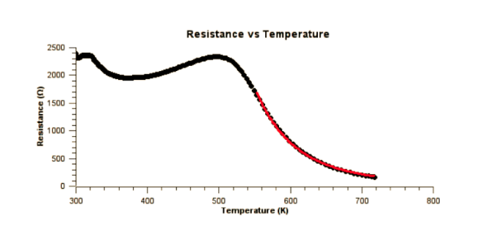**Description of Expected Output**

We expect to produce a resistance and temperature curve similar to the one seen on the right and based on that calculate the bandgap energy.

**Safety Concerns**

Given the ceramic oven’s high operating temperatures, safety protocols, including the use of insulating gloves, will be strictly observed to mitigate risks.

# References

|  |  |
| --- | --- |
| [1] | *Semiconductor Bandgap Measurements,* Kingston: Queen's University, 2018. |